Peak Element in Sorted Array:-
Optimal Approach(Using Binary Search):
We are going to use the Binary Search algorithm to optimize the approach.
The primary objective of the Binary Search algorithm is to efficiently determine the appropriate half to eliminate, thereby reducing the search space by half. It does this by determining a specific condition that ensures that the target is not present in that half.
Until now, we have found how to identify if an element is a peak. But since binary search works by reducing the search space by half, we have to find a way to identify the halves and then eliminate them accordingly.
How to identify the halves:
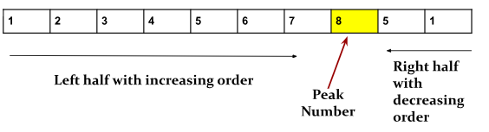
By observing the above image, we can clearly notice a striking distinction between the left and right halves of the peak element in the array.
- The left half of the peak element has an increasing order. This means for every index i, arr[i-1] < arr[i].
- On the contrary, the right half of the peak element has a decreasing order. This means for every index i, arr[i+1] < arr[i].
Now, using the above observation, we can easily identify the left and right halves, just by checking the property of the current index, i, like the following:
- If arr[i] > arr[i-1]: we are in the left half.
- If arr[i] > arr[i+1]: we are in the right half.
How to eliminate the halves accordingly:
- If we are in the left half of the peak element, we have to eliminate this left half (i.e.
low = mid+1). Because our peak element appears somewhere on the right side.
- If we are in the right half of the peak element, we have to eliminate this right half (i.e. high = mid-1). Because our peak element appears somewhere on the left side.
p>Now, let’s see if these conditions are enough to handle the array with multiple peaks. Based on the observation, in an array with multiple peaks, an index has four possible positions as follows:
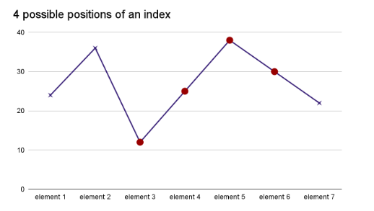
- The index is a common point where a decreasing sequence ends and an increasing sequence begins.
- The index might be on the left half.
- The index might be the peak itself.
- The index might be on the right half.
Until now, we have found how to identify if an element is a peak and how to identify the halves and then eliminate them accordingly. So, the last 3 cases have been resolved. We have to find out how the first case should be handled.
If an index is a common point where a decreasing sequence ends and an increasing sequence begins, we can actually eliminate either the left or right half. Because both halves of such an index contain a peak.
So, we decide to merge this case with the condition If arr[i+1] < arr[i]. You can choose otherwise as well.

Code:-
class Solution {
public int findPeakElement(int[] nums) {
int n = nums.length;
if (n == 1) return 0;
if (nums[0] > nums[1]) return 0;
if (nums[n - 1] > nums[n - 2]) return n - 1;

int low = 1, high = n - 2;
while (low <= high) {
int mid = (low + high) / 2;

if (nums[mid - 1] < nums[mid] && nums[mid] > nums[mid + 1])
return mid;

if (nums[mid] > nums[mid - 1]) low = mid + 1;

else high = mid - 1;
}
return -1;
}
}

